**How to create App Services and Publish File**

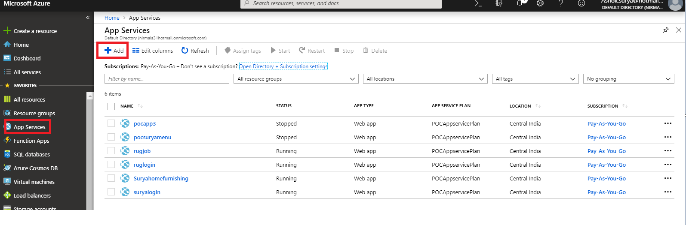

Click on “+Add” hyper link in above screen shot

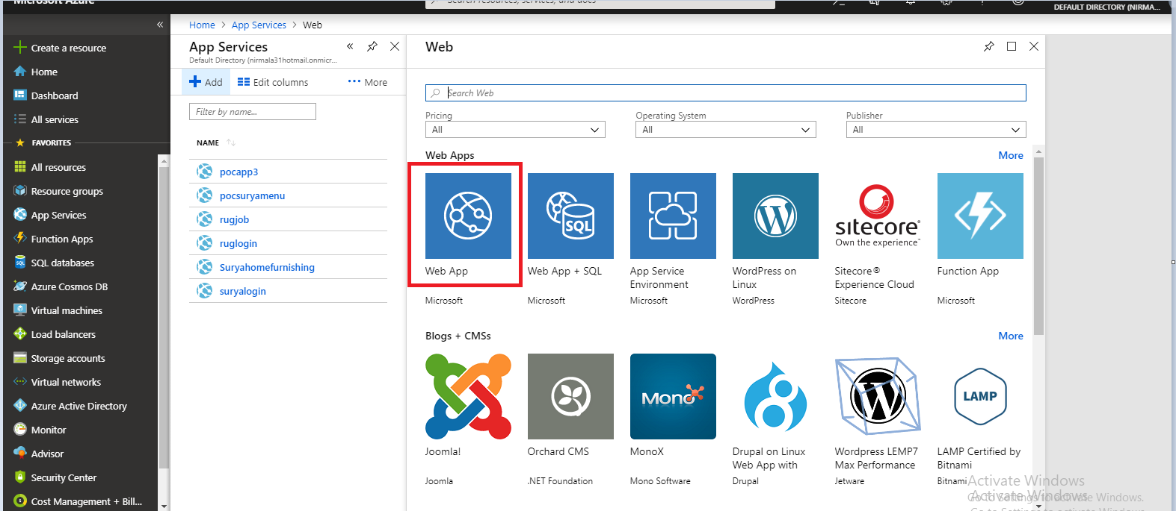

After click on above image on “Web App” open below screen shot

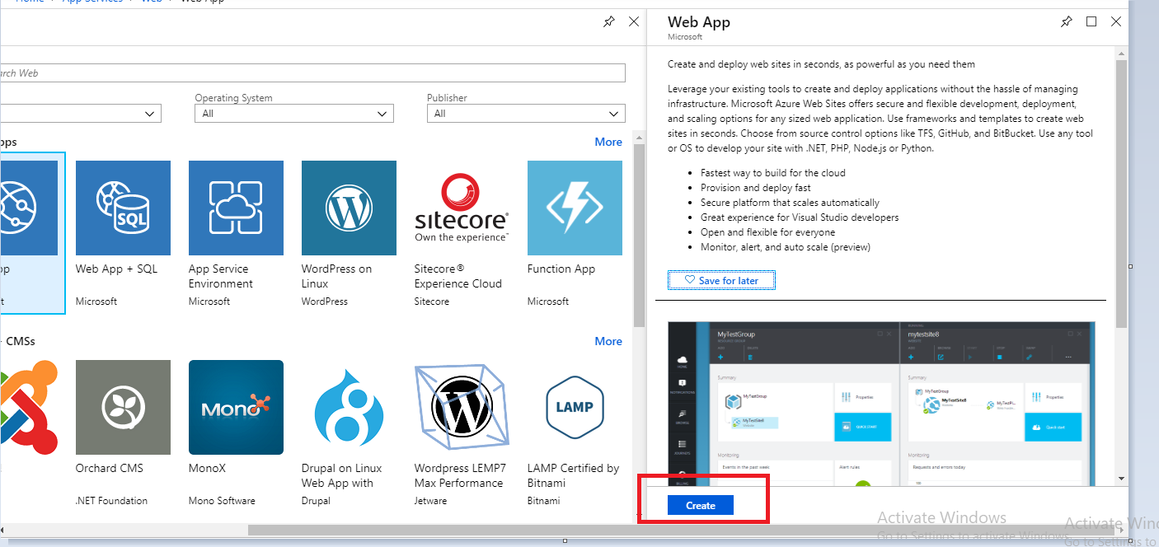

After click on create button on above screenshot, open below screen shot image

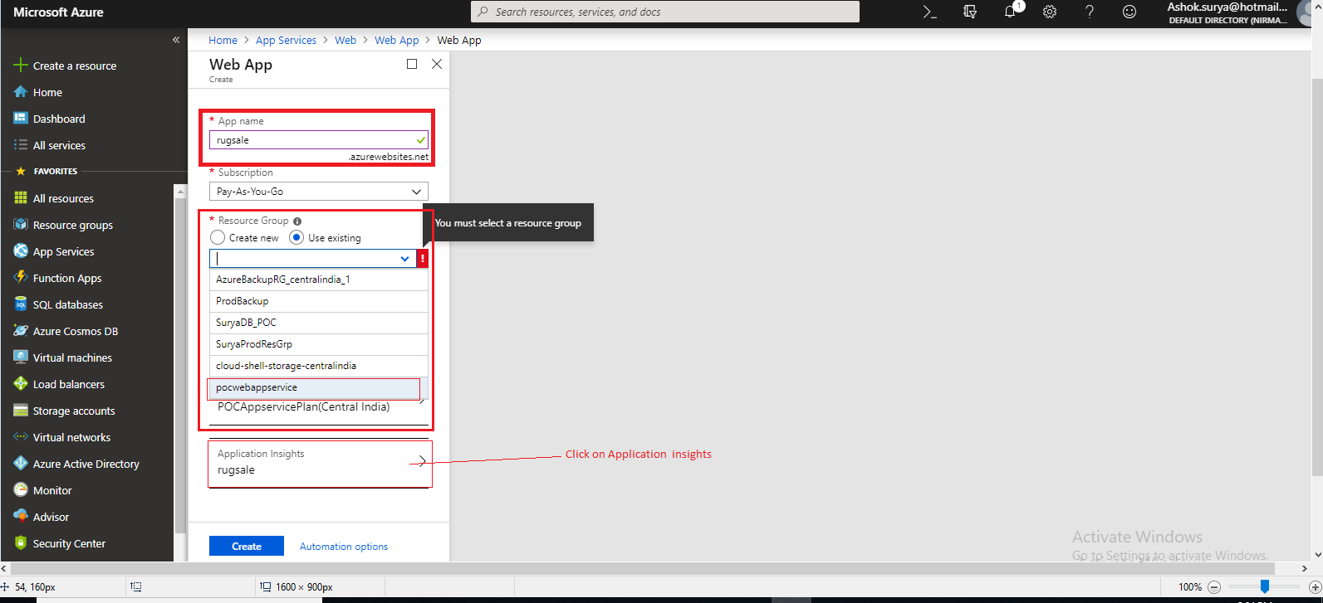

On above screenshot, Click on “rug sale” in [Application Insight box], than open below screen shot

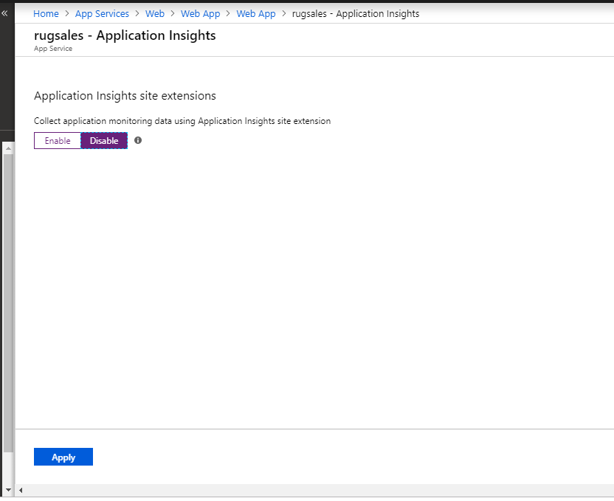

(On above screen shot select “Disable” and Click On “Apply”)

Click on above second image screen shot “Create” below screen shot open

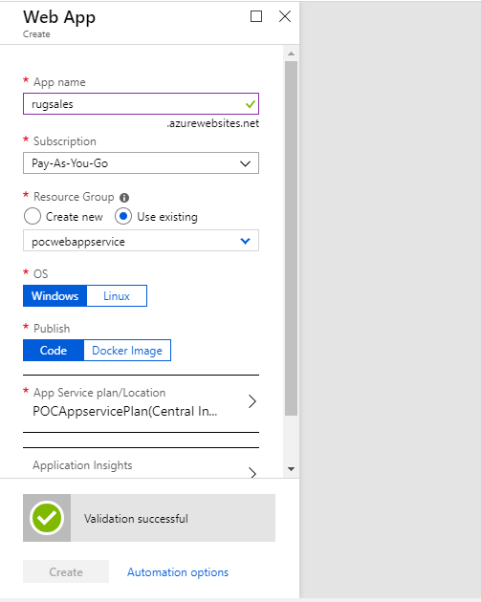

Again go to App services we see added app services name as below screen shot

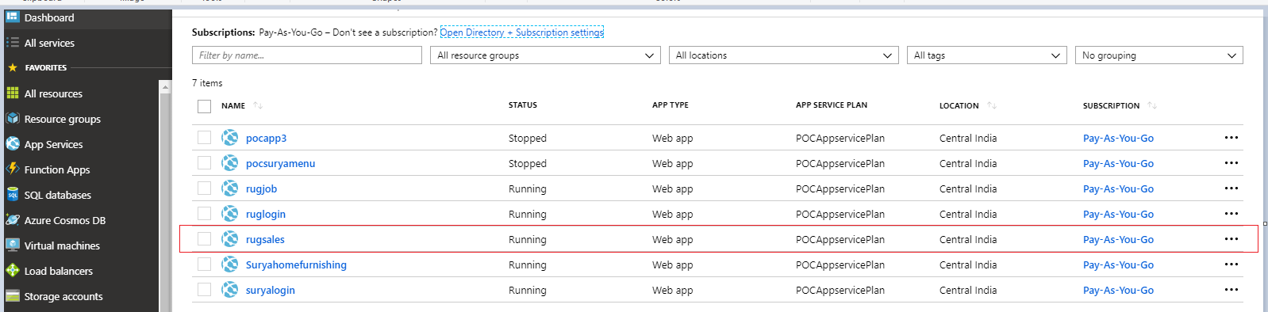

Add HOST NAME below screenshot

Go to App services we should click on “custom domain” than again click on “[+]Add hostname “

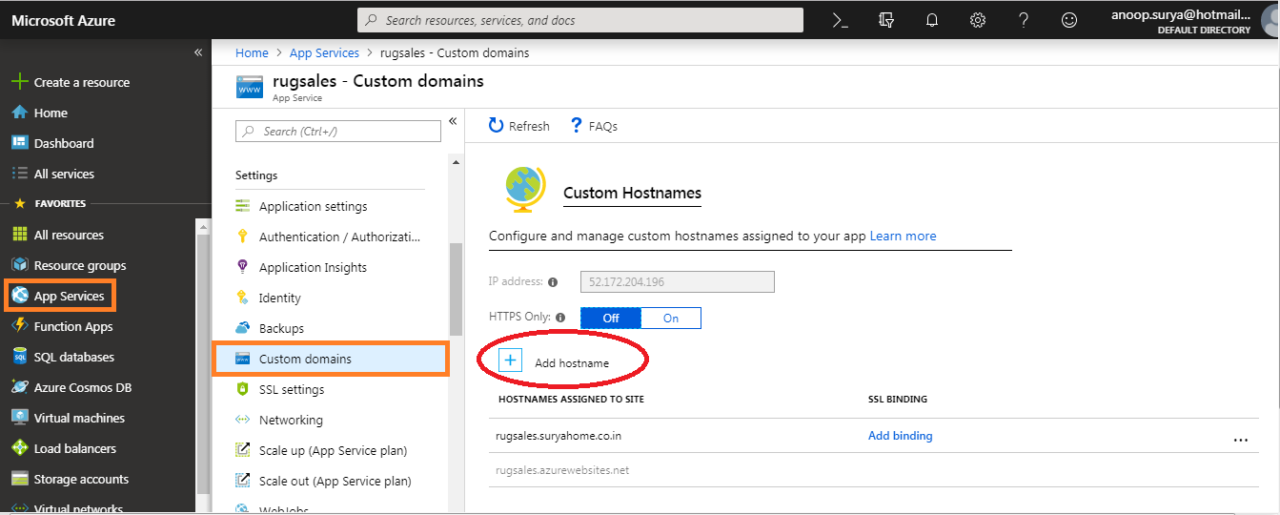

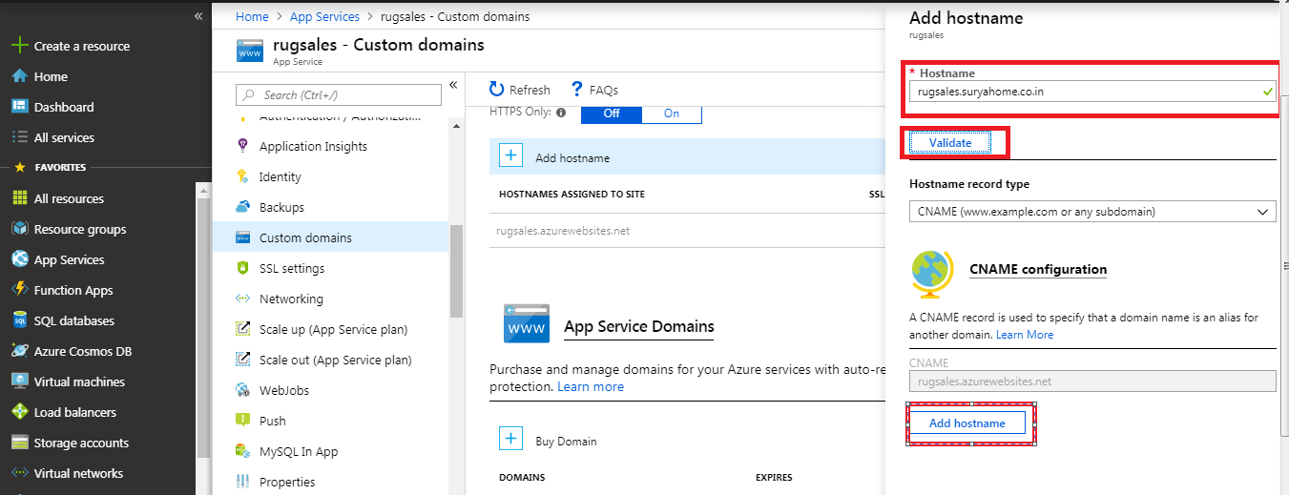

After click on [Add hostname] on above Screenshot, see below screenshot image {a} is under processing & {b}processing successful Bind hostname

{a}

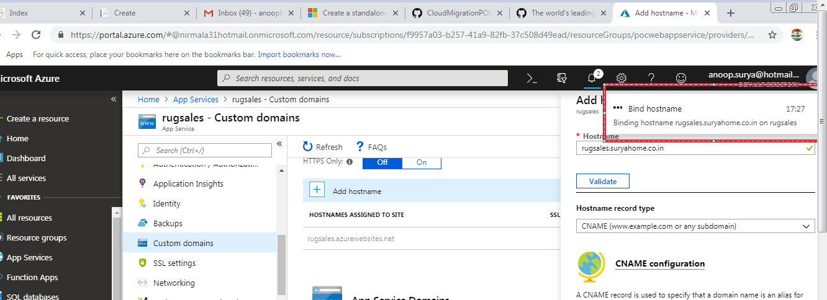

{b}

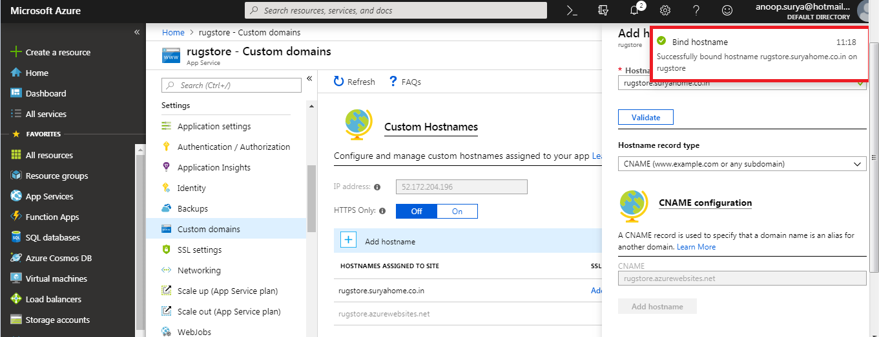

Last process is how to download Get publish profile for each Module

Finally In below screenshot, we click on ” Get Publish Profile” for download

